Windows Application Automation

Contents

A. Installation 2

1. Python 2

2. Windows Application Driver 2

3. WhiteAppLibrary project 3

1. WhiteLibrary 3

2. SikuliLibrary 5

3. AppiumLibrary 6

B. Customization 10

1. SikuliLibrary 10

C. Common Question 11

1. How to add a path into Path environment variable? 11

2. How to create a new Interpreter in Pycharm? 12

# Definition

## 1. Python

# Installation

## 1. Python

Step 1: Download and install Python latest version (ver. 3.7.3 as May 2019) at: <https://www.python.org/downloads/>

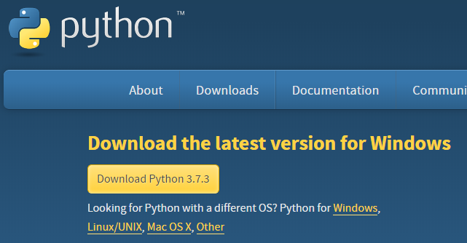

Step 2: Add its installation path into PATH environment variable. Go to **Common Question** section to know how to “Add Path environment variable”.

## 2. Net framework

## 3. WhiteAppLibrary project

Step 1: Pull (or download) this project from GitHub:

<https://github.com/mtran21081990/WinAppAutomation/tree/master/SampleProjects/WhiteLibraryAutomation>

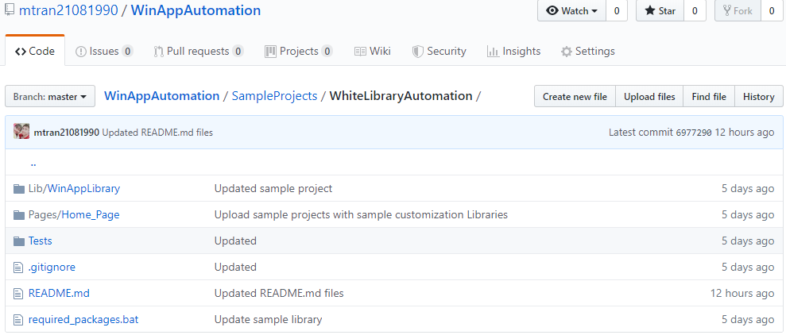 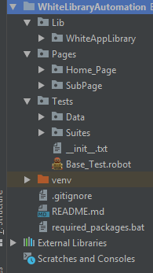

**Project Details**:

* Lib > WinAppLibrary: contains the customized library which is extended from WhiteLibrary
* Pages: contains resource files for each module of an application. With a desktop application, each Window should be considered a module.
* Tests > Data: contains test data for each test suites.
* Tests > Suites: contains test suites.

Step 2: Open a Python IDE (prefered PyCharm), then open the WhiteLibraryAutomation project. Create a new Interpreter for this project in File > Settings > Project Interpreter. Restart IDE (if need). Go to **Common Question** section to know how to “Create a new Interpreter on Pycharm”.

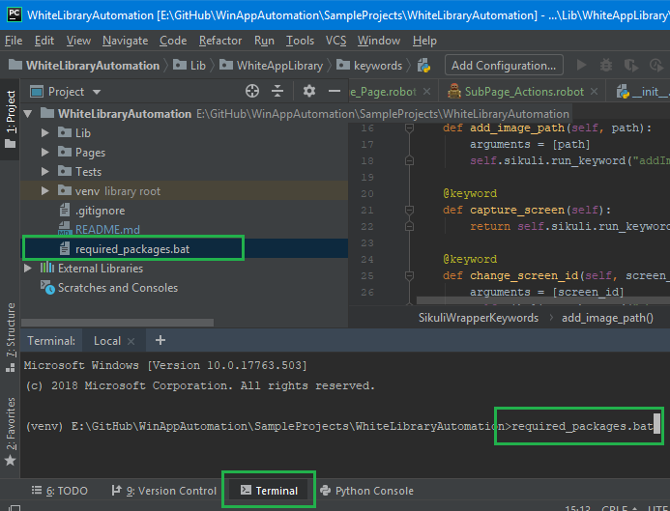Step 3: Install all required packages for the project:

- Open **Terminal**

- Input “required_package.bat”

- Press ENTER.

🡺 This will install the following libraries: robotframework, robotframework-SikuliLibrary, robotframework-appiumlibrary and pyyaml.

## 1. WhiteLibrary

Step 1: In an existing or new python project, open Terminal and execute following command:

pip install --upgrade robotframework-whitelibrary

Step 2: Verify installed packages in Files > Settings: pythonnet, robotframework (if not) and robotframework-whitelibrary.

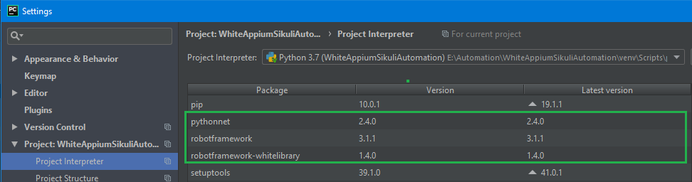

Step 3: Verify WhiteLibrary by composing and running a simple test case as follow:

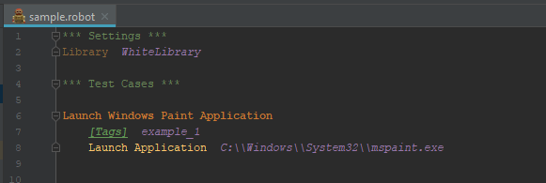

## 2. SikuliLibrary

Step 1: In an existing or new python project, open Terminal and execute following command:

pip install robotframework-SikuliLibrary

Step 2: Verify installed packages in Files > Settings: robotframework (if not) and robotframework-SikuliLibrary.

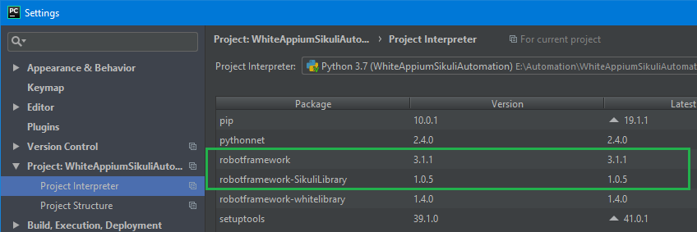

Step 3: Verify SikuliLibrary by composing and running a simple test case as follow:

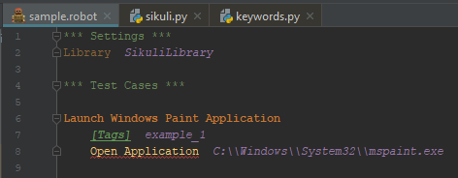

## 3. AppiumLibrary

Step 1: In an existing or new python project, open Terminal and execute following command:

pip install robotframework-appiumlibrary

Step 2: Verify installed packages in Files > Settings: robotframework (if not), kitchen, decorator, urllib3, selenium, six, docutils, Appium-Python-Client and robotframework-appiumlibrary.

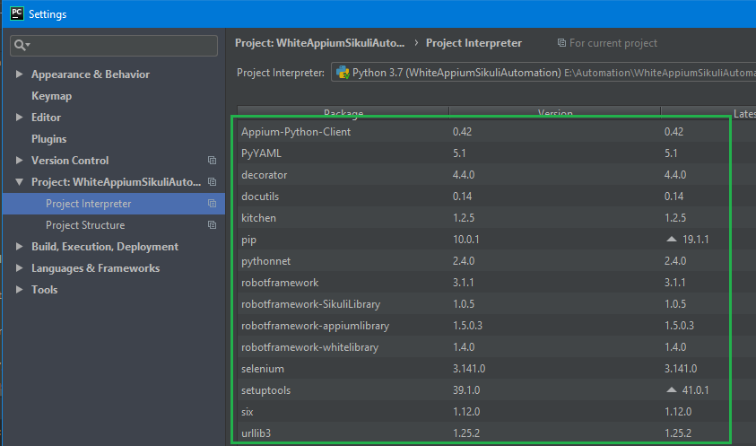

Step 3: Install Appium Desktop application by going to <https://github.com/appium/appium-desktop> and click on **Release** tab to download the latest version of Appium.

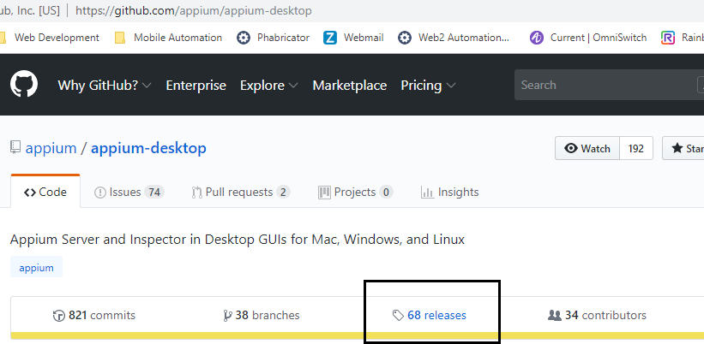

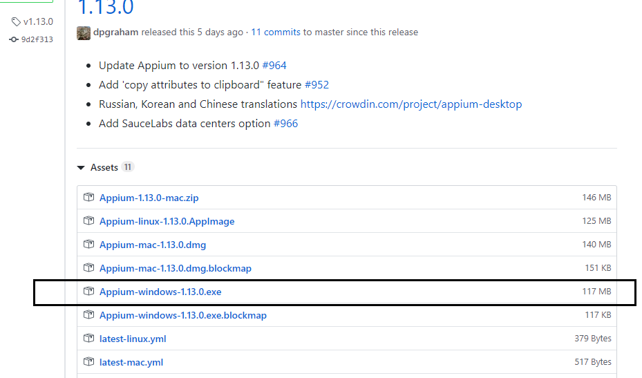

Step 4: Install Windows Application Driver (WinAppDriver) by going to <https://github.com/microsoft/WinAppDriver> and click on **Release** tab to download the latest version of WinAppDriver.

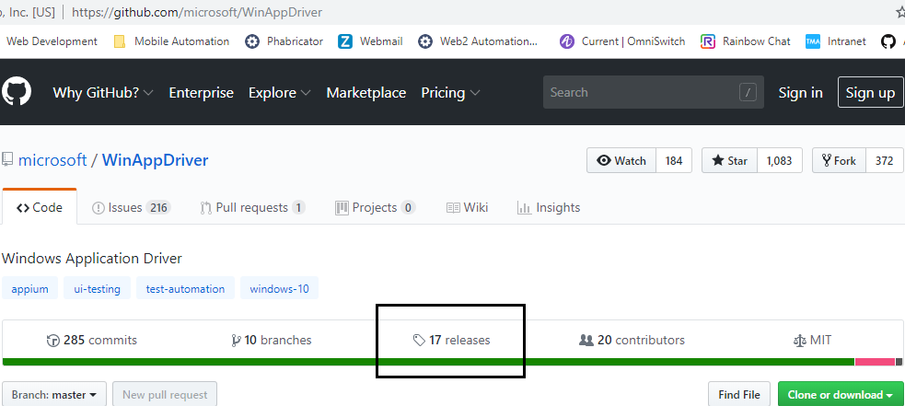

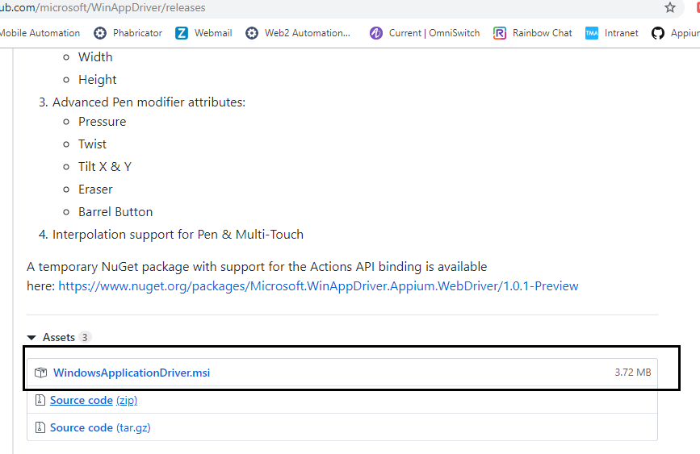

Step 5: Enable Developer mode on Windows by going to Settings:

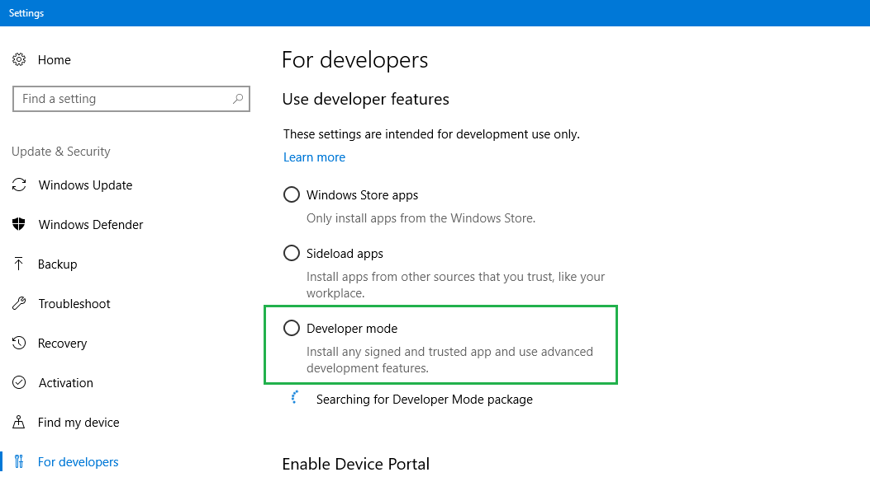

Step 6: Install Appium Desktop & WinAppDriver applications. Run Appium Desktop application and Start Server (default port is 4723).

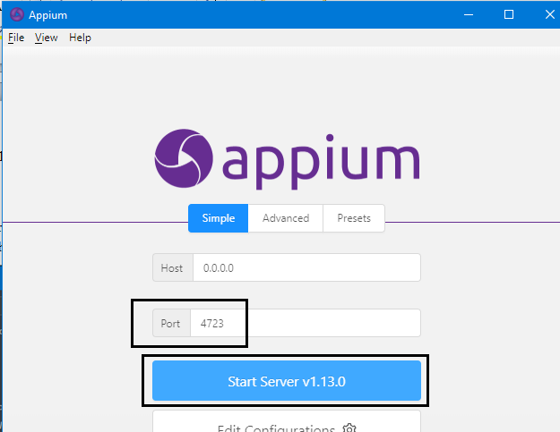

Step 7: Verify AppiumLibrary by composing and running a simple test case as follow:

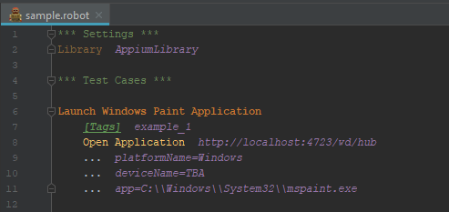

# Customization

## 1. SikuliLibrary

# Common Question

## How to add a path into Path environment variable?

Step 1: Right click on **My Computer** and select “Properties” to open **System** dialog. On **System** dialog, click “Advanced system settings” to open **System Properties** dialog.

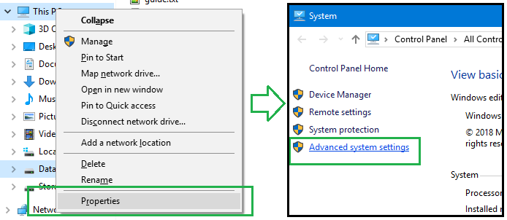

Step 2: On **System Properties** dialog, open “Advanced” tab, click “Environment Variables” button to open **Environment Variables** dialog. Add the new path into a ‘Path” variable (one is enough).

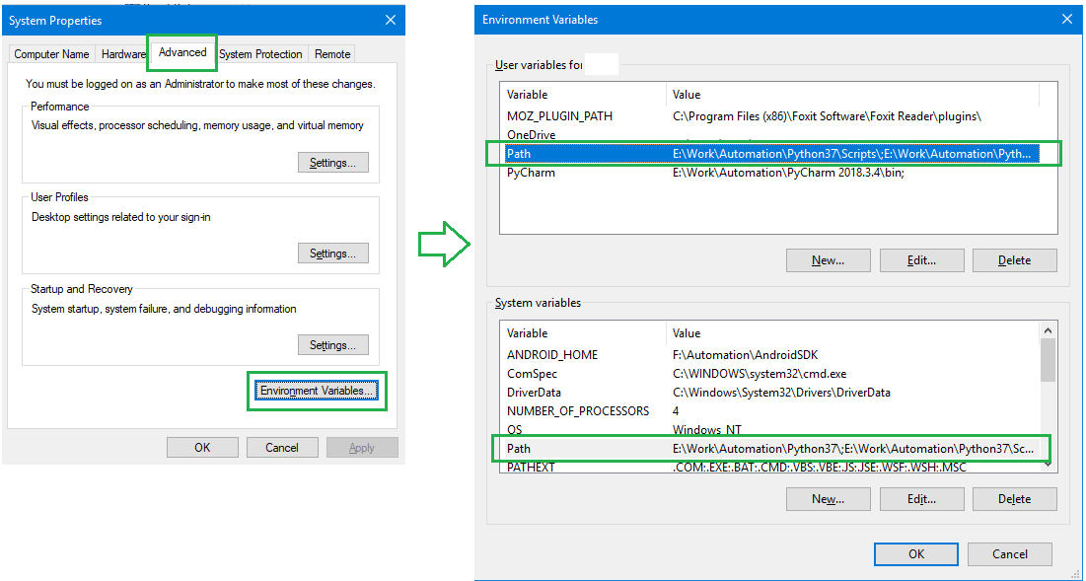

## How to create a new Interpreter in Pycharm?

Step 1: Open “File” on top menu and click “Settings” to open **Settings** dialog.

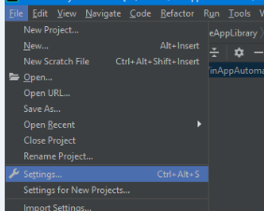

Step 2: On **Settings** dialog, open “Project Interpreter”, on the right section click on the **Gear** icon and select “Add” to open **Add Python Interpreter** dialog.

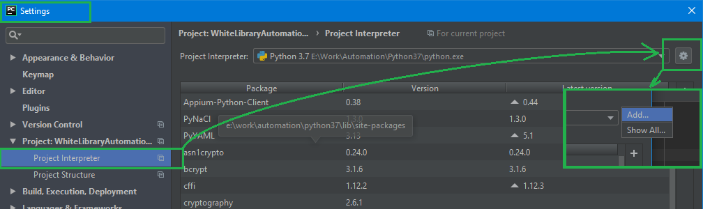

Step 3: On **Add Python Interpreter** dialog, select “New environment” radio button and uncheck any checkboxes. Click **OK** button.

